**SOFTWARE WNGINEERING – CSA1072**

**DAY3 PROGRAMS (21 AUG 2023)**

FLOWCHART OF PALINDROME (RAPTOR)

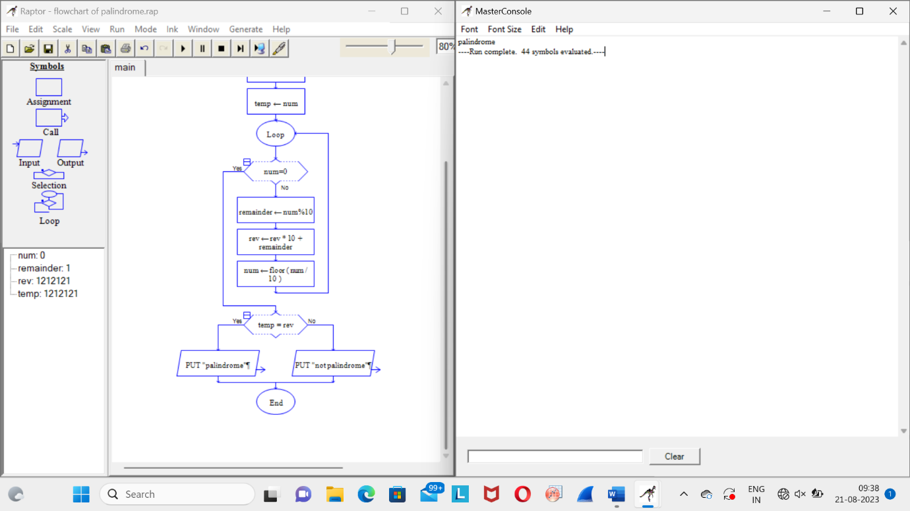

FLOWCHART OF STRING HANDLING (RAPTOR)

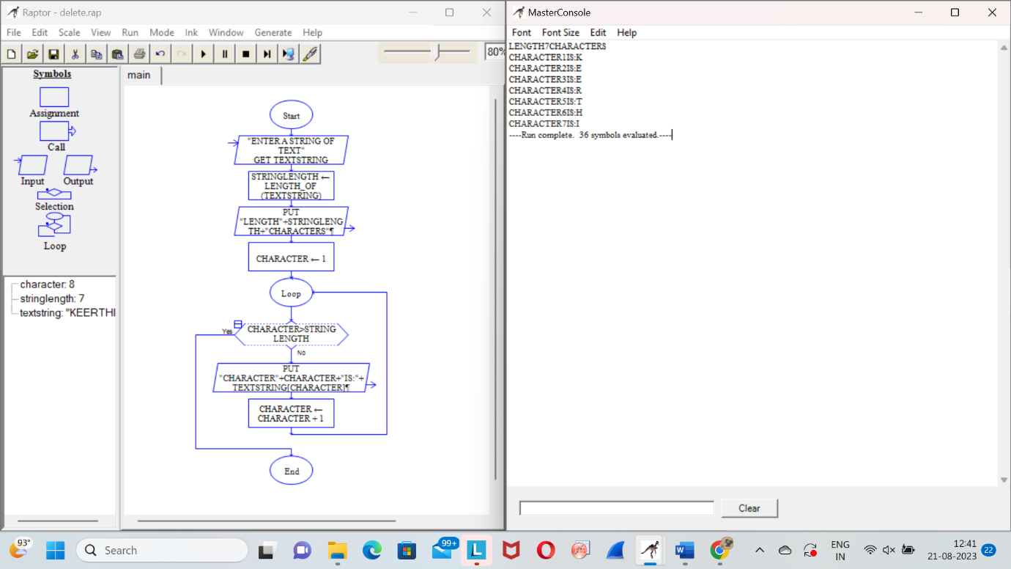

FLOWCHART OF RSA ENCRYPTION SYSTEM (RAPTOR)

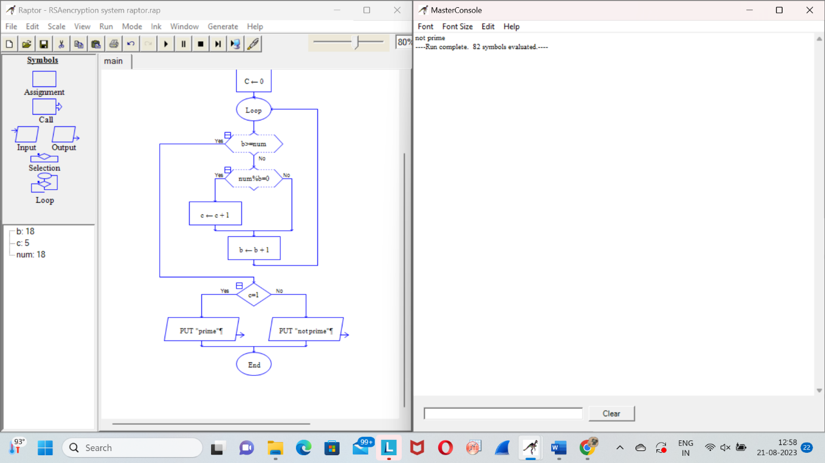

FLOWCHART TO CALCULATE FACTORIAL (RAPTOR)

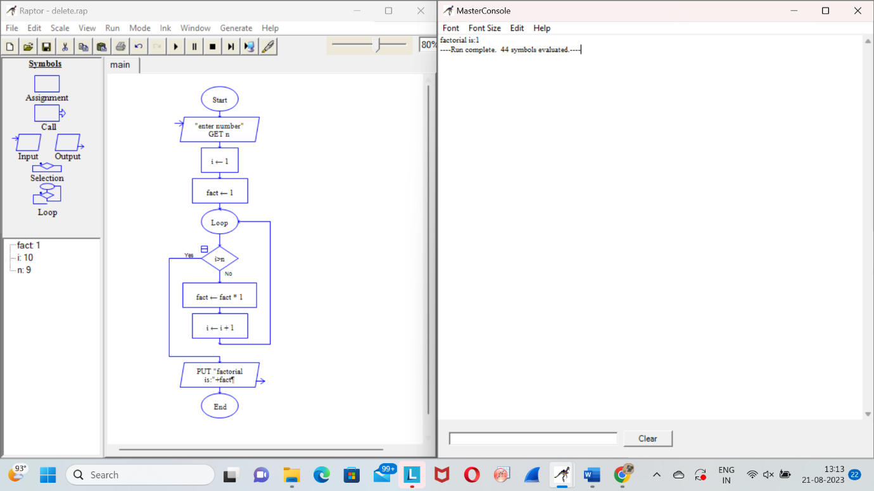

FLOWCHRT OF ODD SERIES (RAPTOR)

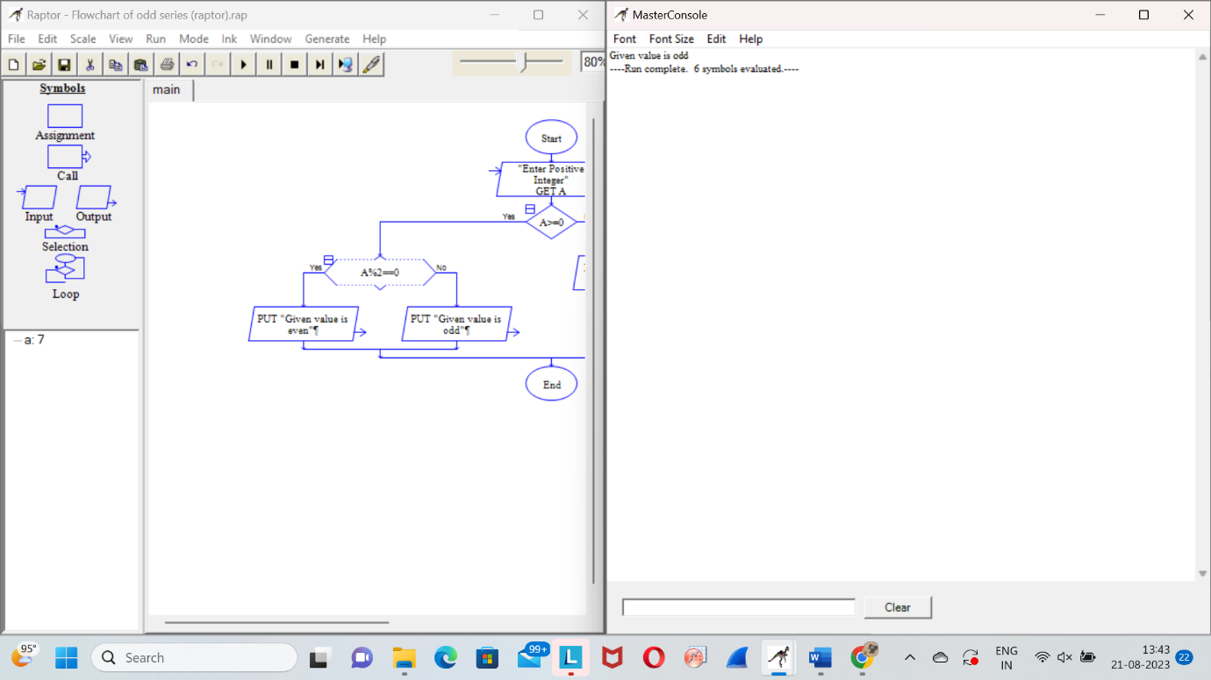

FLOWCHART OF REVERSE OF STRING (RAPTOR)

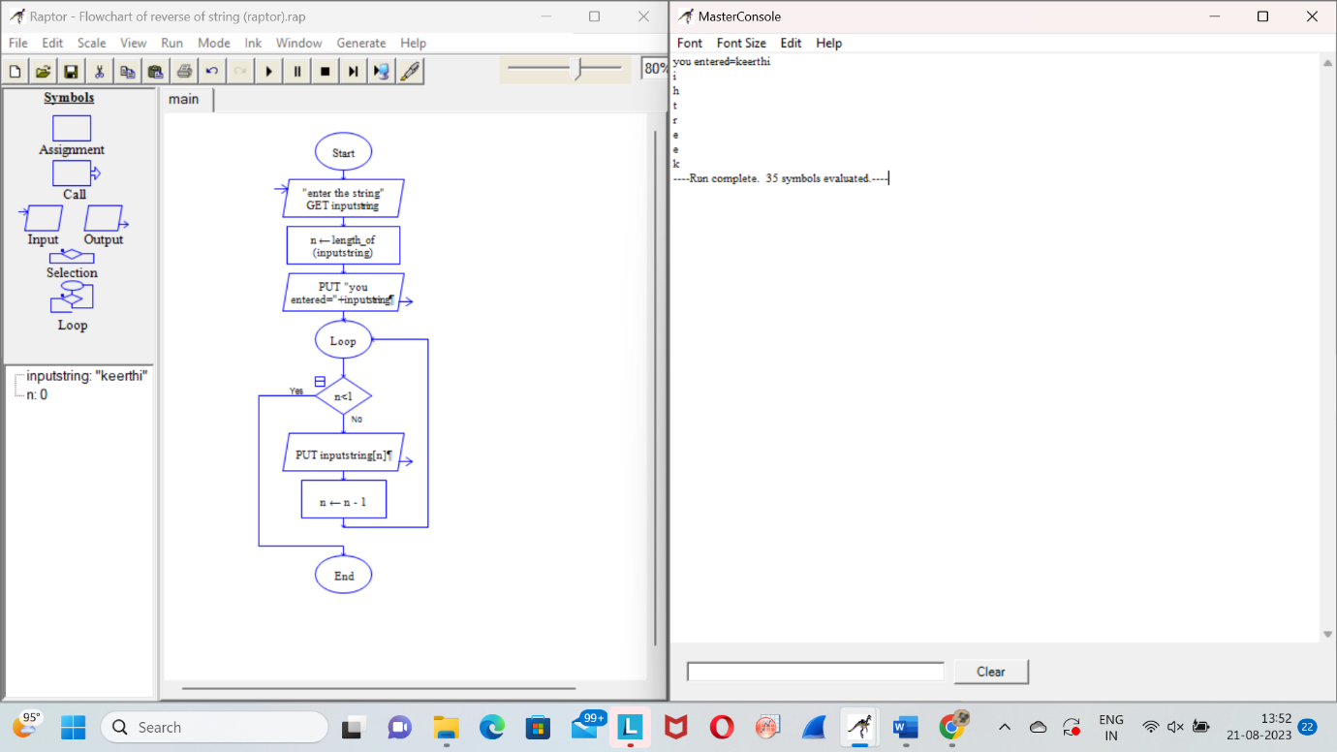

FLOWCHART OF NATURAL NUMBERS (RAPTOR)

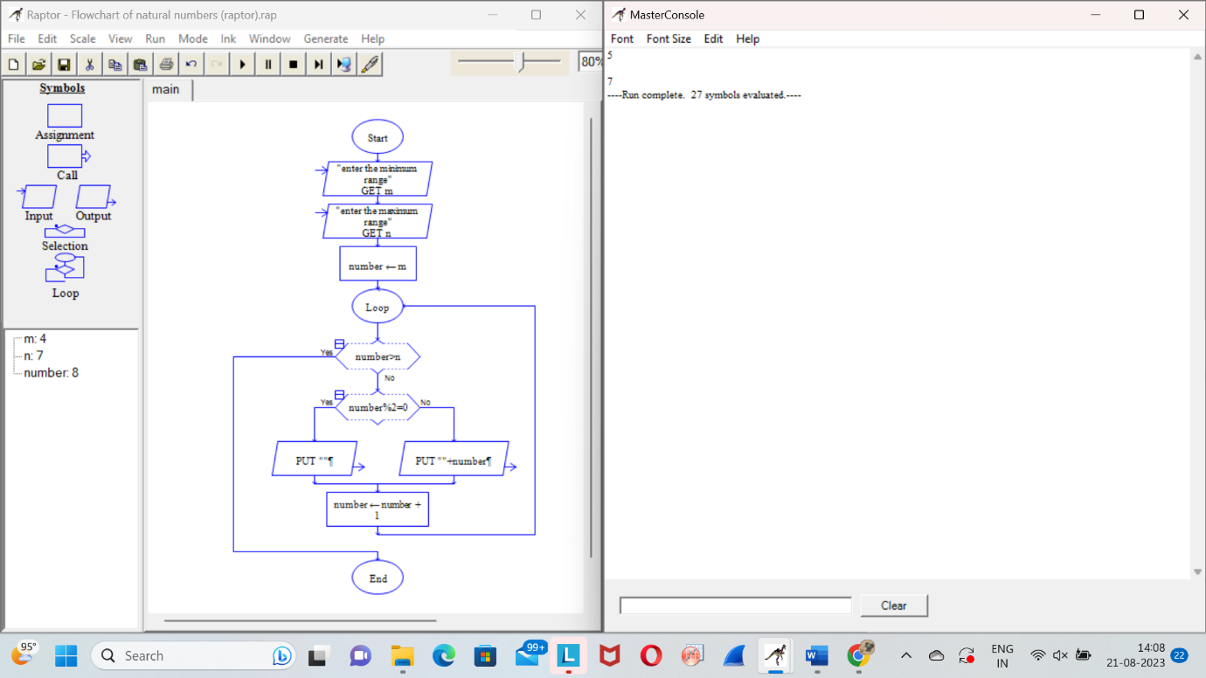

FLOWCHART OF SHELL SCRIPT (RAPTOR)

